Barnet Public Health
4th floor
Colindale Office
2 Bristol Avenue
NW9 4EW

September 2022

Dear Headteacher and Resilient Schools Lead

Barnet Resilient Schools Programme – Welcome letter

We are delighted that your school is part of the Barnet’s Resilient Schools (RS) Programme which seeks to promote whole school awareness of wellbeing, mental health, and resilience, by offering development opportunities for pupils, staff, and parents.

The programme aims are to:
• Help staff, parents/ carers, and pupils to recognise their own mental wellbeing needs and be confident to access information to support themselves and others.
• De-stigmatise mental health problems in schools.
• Intervene early to prevent escalation of mental health problems.

The RS programme is underpinned by six core components which are evidence-based and champion best practice. Figure 1 below, lists the core components and details the importance of each component in building mental health and emotional resilience in schools:
The RS Mapping Tool
A reflection document that requires schools to note down actions taken to support mental health and wellbeing under each principle of the whole school approach.
Digital Resilience
Working within the eight guiding principles to a whole school approach, Barnet has added the ninth principle of ‘Digital Resilience’ in recognition of the unique generational challenges that young people face today.
Physical Activity
Successful promotion of physical activity has been shown to reduce anxiety, increase resilience, improve well-being and increase positive mental health in children and adolescents.
Self-harm & suicide prevention
Children and adolescents are a vulnerable population to self-harm & suicide ideation. Early intervention is key.
Kooth (for young people 11+) & Qwell (for school staff and parents/carers) online counselling
Supporting individiuals to talk about their mental health & get support is important to build emotional resilience and mentally healthy schools.
Mental health awareness
It is crucial to reduce mental health stigma and spot the signs of poor mental health for early intervention.

We are pleased to announce that the Resilient Schools programme is now a universal programme and is open to all schools in Barnet. As part of our fully funded universal offer your school can access any support and training offered at no cost. In addition, we are now able to provide a way for schools to evidence the whole school approach to mental health awareness and display the Resilient Schools Kitemark in recognition of your achievement.

Universal Offer

The Resilient Schools Programme takes a whole-school approach to promote and build resilience in schools and address mental health concerns early on. It does this by offering the following (Figure 2):

Providing and promoting mental-health focused networking opportunities
RS Network meeting
Resilience in Schools forum
Pastoral Forum
Organising and promoting mental-health focused training
Youth Mental Health First Aid
Mindfulness
MH Awareness
Creating and recommending resources with a mental-health focus
RS Self Harm & Suicide Policy template, which can be added an existing safeguarding or mental health policy
Anna Freud
Developing and cascading mental health promoting initiatives, campaigns & evidence-based recommendations
Promotion of non-PE additional activity and the impact on Mental Health
RS Digital Resilience Campaign
Offering tailored setting support
1:1 support through email, call, virtual meetings
RS Mapping tool – is a strength based audit and includes a progress tracker
Commissioning and signposting to services that support mental health resilience
Barnet Integrated Care Services
Kooth (for young people)
Qwell (for adults)
Healthy Schools London

RS Programme’s Offer Highlights

RS Network Meeting

Attend termly RS network meetings to get updates on the RS programme activities, local services and projects taking place to benefit schools and/or children and young people. In addition, it is also an opportunity to connect with others and share good practice. Please RSVP the meeting invites sent out for the sessions.

Pastoral Forum

Barnet Family Services & Public Health are pleased to continue to offer the Pastoral Forum. The forum is open to any Barnet school staff who provide mental health support to pupils. The forum is a supportive space where networking and CPD opportunities are available, including guest speakers and promotion of staff wellbeing. BICS (Barnet Integrated Care Services) is kindly continuing to offer case consultation at each meeting. Helpful local organisations, that are involved in the emotional welfare of children & young people, such as these meetings will be face to face.

Resilience in Schools (RIS) Forum

We invite you to our RIS sessions, where the Barnet Inclusion Advisory Team will be delivering training/resources and discussion around the key principles of the ‘Whole School Approach’. The forum is open to any Barnet school staff who provide mental health support to pupils and is a supportive space where networking and CPD opportunities are available. There will be six sessions in total and will be hosted on zoom (see flyer attached).

RS Digital Resilience Campaign

The campaign aims to promote digital resilience in children & young people by raising awareness of the impacts of the digital world on health and wellbeing and support them to become more digital resilient. To keep young people at the heart of the campaign a Digital Resilience youth-led promotional film called ‘Generation Verified’ was produced. A launch for schools with accompanying digital resilience school packs corresponding with the film, including links to lesson plans, signposting, help and advice; tailored to teachers, parents, and pupils is in planning.

Dates for events and training can be found in the Resilient Schools Calendar. Invites where appropriate, will also be sent out to schools.

Achieving the Kitemark

Completing the Core Components

To obtain the Resilient Schools Kitemark, a school will be required to complete all the relevant actions for each RS programme core component type. See Figure 3 below, for more details:
Schools will need to complete the following actions:
Component Type
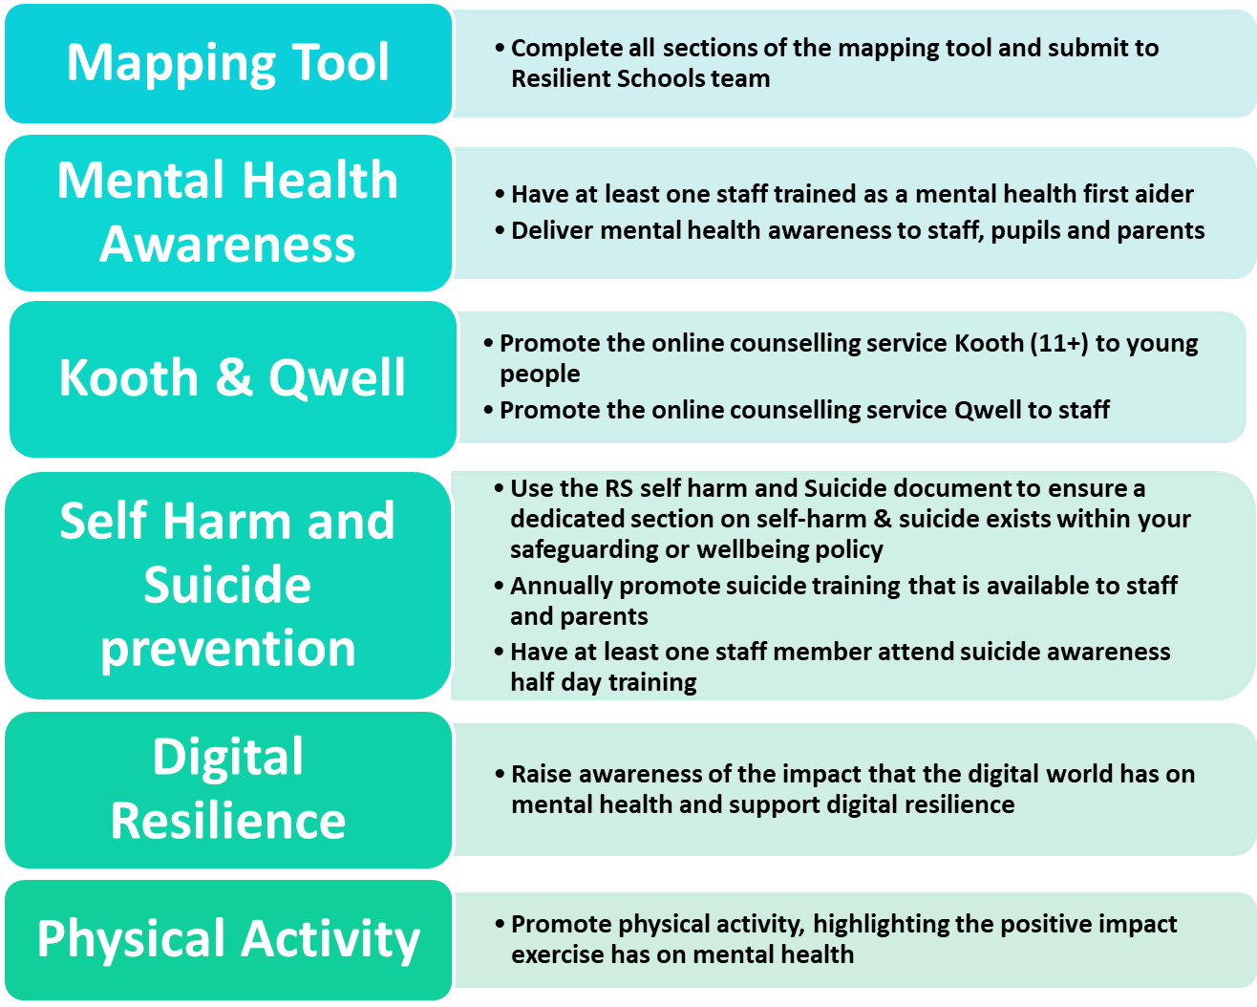
C
O
R
E

C
O
M
P
O
N
E
N
T
S

The ability as a school to promote and raise awareness is a running theme for the successful completion of the RS core components (except the mapping tool). There is a variety of local and external mental health-related resources and school-based activities that could be used to promote and raise awareness for each relevant RS component type. For example, for the digital resilience component, if you are a secondary school, you can use resources from the RS digital resilience campaign, to raise awareness of the impact that the digital world has on mental health and support digital resilience.

More examples of how you can promote and raise awareness for the relevant different RS core components can be found in Figure 4 below:
Examples of activities to assist with completing the core components
Foster Digital Resilience (DR)
Share the 'Generation Verified' film with pupils
Utilise the DR resource pack (includes lesson plans for PSHE)
Attend DR related training for e.g. Youth gaming mindful resilience workshops.
Promote DR to parents/carers for e.g. in newsletters, coffee mornings, etc.
Promote Physical Activity (PA)
Sign up to a physical activity intiative
Engage in physical activity school challenges
Sign up to GLL Activate assemblies
Signpost families to PA opportunities
Offer extra PE lessons
PSHE lessons on the benefits of PA
Take Self Harm & Suicide prevention action
Use the Self Harm and Suicide Document in your safeguarding policy
Deliver a PSHE session on mental health & signpost to further support
Ensure you have at least one MHFA and one person trained in suicide prevention
Promote Kooth & Qwell
Book an assembly for Kooth
Book an inset for staff for Qwell
Signpost adults to Qwell in staff meetings & newsletters, screensavers etc.
Display posters of Kooth and Qwell
Raise Mental Health awareness (MH)
Engage with a MH awareness campaigns
MH student sessions (assembly/class)
Host a parent coffee morning
Take part in MH related school projects & research
MH staff inset
Wellbeing page on your website
Links sent out to parents

How to Apply for the Kitemark

The mapping tool is not only a core component but is the document that is to be used to record the core-component actions you have completed. The actions must be written in the progress tracker section of the mapping tool. Submit the finished version of the document to the Resilient Schools team to receive the Kitemark.

Using RS for a Healthy Schools London Silver or Gold award

If a school chooses to use the Resilient Schools programme (choosing the core components as their silver template actions) for their Healthy Schools London silver and gold award, to reduce duplication, schools will not have to complete the RS mapping tool to obtain the Kitemark. Instead, relevant actions can be recorded on the Resilient Schools HSL silver award template. As soon as schools successfully submit their Resilient Schools HSL silver award template, and it is checked by the Resilient Schools team, they will be awarded the Kitemark. Settings who used Resilient Schools to successfully achieve their silver and/or gold HSL award in the 21/22 academic year, will not need to apply for the Kitemark and will receive the Kitemark at the time of agreed awarding (July 23) for the 22/23 academic year.

Submission Frequency and Deadlines

Submissions for the kitemark will need to be made before June 2023. Awards will be presented in the month of July. The kitemark last for 2 years, 2023-2025. You will then need to repeat the mapping tool and evidence the core components in the academic year of 2025 to receive the kitemark for 2026-2028.

If a school is using the RS programme (choosing the core components as your silver template actions) for their Healthy Schools London silver and gold award, schools will not have to wait to be awarded their HSL silver or gold status to achieve the kitemark.

If you have any queries or need 1:1 setting support, please do not hesitate to contact a member of the Resilient Schools team:
- Jayne Abbott- Resilient Schools Programme Manager, Jayne.abbott@barnet.gov.uK
- Orla Purdon- Health Improvement Officer for secondary schools, orla.purdon@barnet.gov.uk
- Michelle Leon-Health Improvement Officer for primary schools michelle.leon@barnet.gov.uk

Yours faithfully,
Jayne Abbott
Resilient Schools Programme Manager
Barnet Public Health

