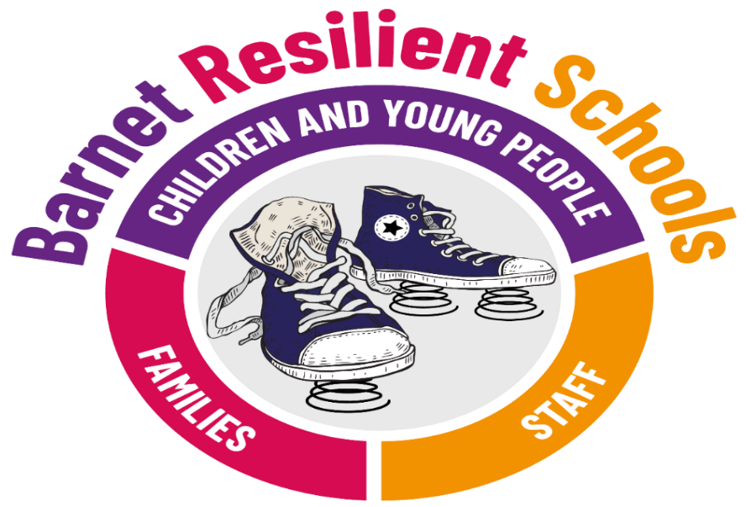



The Department for Education (DfE) recognises that: “in order to help their pupils succeed; schools have a role to play in supporting them to be resilient and mentally healthy”. There is good evidence to support this assertion and Ofsted has highlighted that children and young people themselves say that they want to learn more about how to keep themselves emotionally healthy. Moreover, schools have a duty to promote the wellbeing of students.
Resilient Schools Mapping Tool 2023/2024

Please return the completed form to:
Primary schools-Michelle Leon, Health Improvement Officer, michelle.leon@barnet.gov.uk
Secondary schools- Orla Purdon, Health Improvement Officer, orla.purdon@barnet.gov.uk

Contact Sheet
School | Edgware Primary School
No. of pupils
 | Name | Job title | Contact Telephone | Contact email
Resilient Schools Lead
Mental Health Lead
Peer Mentoring Lead
(Secondary schools only)
Mindfulness Lead
(optional)
Mental Health First Aiders

Physical Activity Lead
(optional)
Person Completing the Mapping Tool
Are you happy to share good practices with others? | Yes/No
Are you able to offer a venue for a Network Meeting/Training? | Yes/No

Eight Principles to Promoting a Whole School and College Approach to Emotional Health and Wellbeing
The following diagram presents 8 principles to promote emotional health and well-being in schools and colleges.
on, anger
Curriculum,
teaching and
learning to promote
resilience and support
social and emotional
learning
Enabling
student voice
to influence
decisions
Staff
development
to support their own
wellbeing and that
of students
Identify need and
monitoring impact of
interventions
Working with
parents/carers
Targeted
support and
Appropriate
referral
An ethos and
environment that
Promotes respect
And values diversity
Leadership and management
that supports and champions
efforts to promote emotional
health and wellbeing

To read more about the whole school approach….
https://assets.publishing.service.gov.uk/government/uploads/system/uploads/attachment_data/file/958151/Promoting_children_and_young_people_s_emotional_health_and_wellbeing_a_whole_school_and_college_approach.pdf

STRENGTHS | CHALLENGES
Leadership and Management Key question: How is the school or college providing visible senior leadership for emotional health and well-being?

Links with the Ofsted inspection framework: One of the 4 key Ofsted judgements is “the quality of leadership in and management of the school”. xxii Schools have to demonstrate how effective leadership and management enable all pupils to overcome specific barriers to learning, for example through effective use of the pupil premium and sports premium, and the extent to which leaders and managers create a positive ethos in the school. The framework also specifies that schools should demonstrate a capacity for further improvement, for example by working in partnership with other schools, promoting children and young people’s emotional health and well-being in early years providers, external agencies and the community; as well as by engaging with parents
Curriculum, Teaching and Learning Key question: What focus is given within the curriculum to social and emotional learning and promoting personal resilience, and how is learning assessed?

Links with the Ofsted inspection framework: The quality of teaching in the school is a key Ofsted judgement area. The inspection criteria state that the role of teaching is to promote learning and the acquisition of knowledge by pupils and to raise achievement, but also to promote the pupils’ spiritual, moral, social and cultural development.
Student Voice Key question: How does the school or college ensure all students have the opportunity to express their views and influence decisions?

Links with the Ofsted inspection framework: Ofsted Inspectors must have regard for the views of pupils. When assessing the level of behaviour and safety in schools, inspections should look at a small sample of case studies to evaluate the experience of particular individuals and groups, including disabled pupils and those who have special educational needs, looked after children and those with mental health needs.
Staff development, Health and well-being Key question: How are staff supported with their own health and well-being and to be able to support student wellbeing?

Links with the Ofsted inspection framework: The quality of teaching is a key judgement area for Ofsted. The inspection criteria refer to the importance of ensuring that all teaching staff benefit from appropriate professional development and that performance is rigorously managed.
When assessing leadership and management, inspectors must consider the school’s use of performance management and the effectiveness of strategies for improving teaching. This should include the extent to which professional development is based on the identified needs of staff and the induction needs of newly qualified teachers and teachers at an early stage of their career
Identifying Need and Monitoring Impact Key question: How does the school or college assess the needs of students and the impact of interventions to improve wellbeing?

Links with the Ofsted inspection framework: When inspecting the quality of leadership in and management of the school Ofsted inspectors should consider the effectiveness of monitoring and evaluation and the extent to which it is shared with governors. They should also consider how well the school meets the needs of all vulnerable groups of pupils.
Assessing and responding to the emotional health and well-being needs of children and learners, and taking steps to mitigate the impact this has on their capacity to learn could provide supportive evidence in relation to all key judgement areas: the achievement of pupils at the school, the quality of teaching in the school, the behaviour and safety of pupils at the school and the quality of leadership in and management of the school.
Working with Parents/Carers Key question: How does the school or college work in partnership with parents and carers to promote emotional health and wellbeing?

Links with the Ofsted inspection framework: The Ofsted inspection criteria expects schools to be engaging parents in supporting pupils’ achievement, behaviour and safety and their spiritual, moral, social and cultural development.
Ofsted inspectors must have regard for the views of parents. Inspectors will also take account of the results of any surveys carried out or commissioned by the school
Targeted Support Key question: How does the school or college ensure timely and effective identification of students who would benefit from targeted support and ensure appropriate referral to support services?

Links with the Ofsted inspection framework: Ofsted inspectors will be interested in how monitoring ensures that individual children or groups of children with identified needs are targeted, and appropriate interventions are secured so that children receive the support
School Ethos and Environment Key question: How does the school or college’s culture promote respect and value diversity?

Links with the Ofsted inspection framework: When judging behaviour and safety Ofsted looks for evidence of a positive ethos that fosters improvements in the school as well as the promotion of safe practices and a culture of safety. As part of the inspection process inspectors will ask to see records and analysis of bullying, including racist, disability and homophobic bullying and will ask young people about their experiences of learning and behaviour in the school, including bullying. The school will be judged on the effectiveness of its actions to prevent and tackle all forms of bullying and harassment.

Sharing Learning – examples of practice
Please share any specific actions, project or initiative that supports learning about mental health in schools. This may be something that has worked well or where you experienced challenges to implementation that would be useful to share with colleagues.
Title
Description
Lessons learnt
Contact for further information
Evidencing the Whole School Approach – Core Components |  | In action/ completed
GUIDANCE- How to fill in the action tracker  - Please put a cross (X) or Yes/No against each core-component action under the appropriate column (i.e., in action/completed or in planning) and provide a brief evidence statement of how you have completed an action.  - We recommend you cross-reference to other sections of this mapping tool document wherever possible to evidence how you have completed an action (see example to the right).  - Please continue to the next page if required |  | Yes-We ran mental health workshops for parents & signpost well-being support in our newsletter; see also pg. 5
Raise Mental Health Awareness | Trained Mental Health First Aider
Raise Mental Health Awareness | Deliver mental health awareness to parents, staff, and pupils  Please refer to the welcome letter (Figure 4) for examples of activities to assist with completing the core components.
Take Self-harm & suicide prevention action | Use the RS self-harm and Suicide document to ensure a dedicated section on self-harm & suicide exists within your safeguarding or well-being policy
Take Self-harm & suicide prevention action | Annually promote free suicide prevention training (zero suicide alliance training) to staff, parents/carers and the school community.
Take Self-harm & suicide prevention action | Have at least one staff member attend suicide awareness half-day training
Promote Kooth & Qwell | Promote the online counselling service Kooth (11+) to young people
Promote Kooth & Qwell | Promote the online counselling service Qwell to staff
Foster Digital Resilience | Raise awareness of the impact that the digital world has on mental health and support digital resilience  Please refer to the welcome letter (Figure 4) for examples of activities to assist with completing the core components.
Promote physical Activity | Promote physical activity, highlighting the positive impact exercise has on mental health  Please refer to the welcome letter (Figure 4) for examples of activities to assist with completing the core components.

